Products | Inclusion: What to ask the patient to see if eligible for PF | Exclusion
Sore Throat:  - Strepsils,  - Difflam spray,  - throat lozenges  - & Pain relief. | Age: >5years +  Minimum of two of the following:  - Coming to your pharmacy within 3 days after onset of symptoms  - No cough or cold symptoms  - Fever (temperature over 38°C)  - Purulence (white spots/puss)  - Severely Inflamed tonsils (may need pharmacist to check | - Is under the age of 16 years and is pregnant, or there is a chance they might be pregnant
Insect Bites:  - Antihistamine cream/tablets  - Hydrocortisone creams | Age: 1 year +  - Presented more than 2 days after bite/sting (no tick).  - Within UK – This does not include bites whilst on holiday abroad- Have they been on holiday?  AND  - Redness & swelling of skin that is spreading.  - Discharge from bite/sting. | - Is under the age of 16 years and is pregnant, or there is a chance they might be pregnant
Otitis Media:  - Calpol,  - Eardrops e.g EarCalm | Age: 1-17 years  - Any patient that presents with ear pain | - Pregnant patients  - Patients that have recurrent earache- 3+ episodes in the past 6 months
UTIs:  - Cystopurin sachets,  - Cymalon  - Potassium Citrate liquid  - Cranberry products,  - Feminine products e.g. Thrush treatment, urine sample bottles? | Age: 16-64 years  Any of the following:  - Urgency  - Frequency  - Having to go at night-time  - Cloudy urine  - Stinging when passing urine  - Pubic pain | - Pregnant patients  - Urinary catheter  - Recurrent UTIs- 2+ in 6 months
Sinusitis:  - Decongestants  - Steroid nasal sprays  - Nasal rinse | Age: >12 years +  Nose runny or blocked for at least 10 days  AND ONE (or more) of:  - Facial pain / pressure / headache.  - Reduced / loss of the sense of smell (in adults)  - Cough during the day or at night (in children) | - Is under the age of 16 years and is pregnant, or there is a chance they might be pregnant  - Immunosuppressed  - Chronic sinusitis >12 weeks.

Shingles:  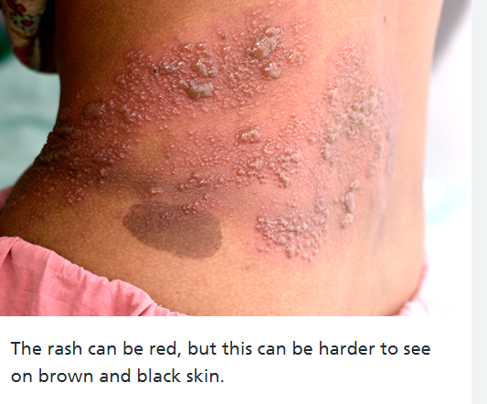 | 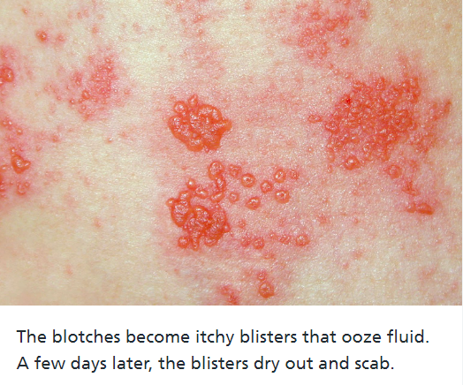 | 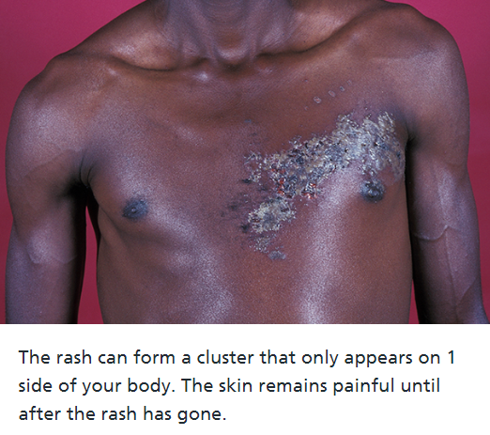
Age: 18 Years +
- Rash appears within 2-3 days after onset of pain and fever, or headache may develop
- Red spots on a pink-red background which turn quickly into small fluid-filled blisters
- On one side of the body

Impetigo:  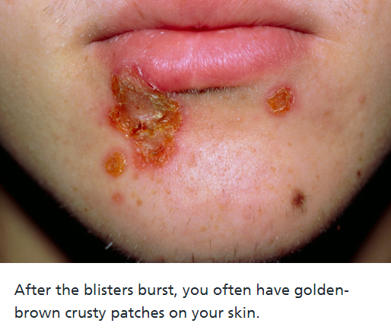 | 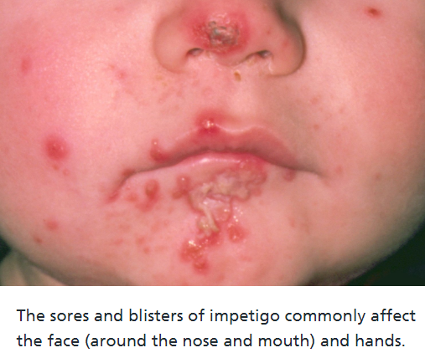 | 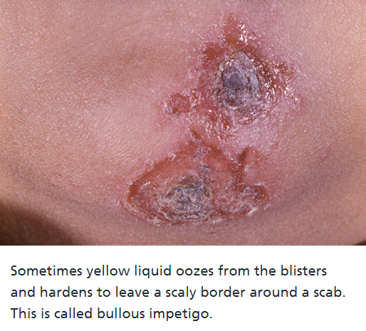
Age: >1year +
- Lesion/crusty yellow/gradually thickens
- Can be anywhere on body but most common face, limbs, bends/folds
- Don’t always present with other symptoms, maybe itchy

