Published on 14 September 2020
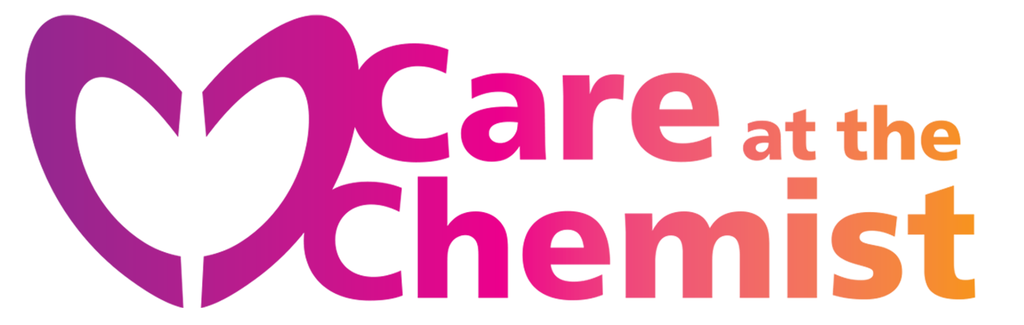
Ask your pharmacist about the NHS Care at the Chemist scheme: advice and treatment for a wide range of minor conditions after a consultation with your pharmacist - no need to visit your GP.
If your prescription is already free, so is any medication provided under this scheme.
The following conditions can currently be treated by this scheme:
Allergies | Indigestion
Athletes foot | Infant colic
Coughs, colds and sore throats | Mouth ulcers
Cold sores | Minor eye infections
Constipation | Minor skin reactions
Cystitis | Nappy rash
Diarrhoea | Nasal congestion
Ear wax | Oral Thrush
Headache | Teething
Pain or temperature | Threadworm
Haemorrhoids | Thrush (genital)
Headlice | Warts and verrucas

